HIGHLIGHTING Particle Physics in Birmingham 2007

Cascade of Particle Physics Competition & Masterclass events for Schools and Colleges

The Particle Physics Research Group PPARC
University of Birmingham

2007 is a big year in Particle Physics as the Large Hadron Collider Experiment set up at CERN in Geneva approaches completion. The Particle Physics group at Birmingham, led by Professor Peter Watkins, have significant involvement with the ATLAS and the ALICE experiments in the LHC ring.

The School of Physics & Astronomy has been running very successful Masterclass events for local AS students for a number of years and this year’s event was made special by a very well received live video link to CERN, where students could ask their questions live to some of the physicists working there.

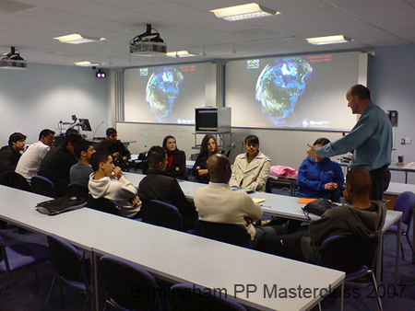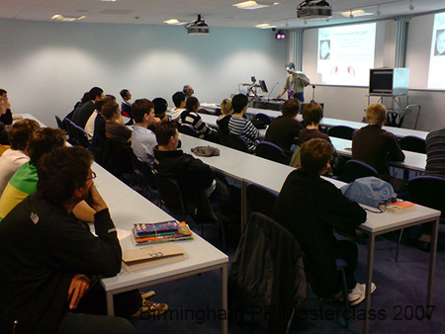
Students enjoying talks & discussions with academic staff and research students

Around 120 Y12 students, and some of their teachers, from 12 schools in Birmingham, Warwickshire, Walsall and Staffordshire, attended the event on April 24th. They enjoyed talks from research students, took part in computing activities to learn about detecting particles, and contributed to discussion sessions and Q & A sessions with academics from Birmingham and CERN itself.

Also this year, a new schools competition was launched – A Cascade of Particle Physics – in which A Level students of Physics from all over the country were invited to prepare interactive presentations to introduce some of the concepts of Particle Physics to younger children in their schools.

27 schools entered the competition, which was launched in November 2006 with an evening event in the School of Physics & Astronomy. A number of the A Level students came to the evening, with their teachers, where they had an opportunity to talk with Particle Physics researchers and undergraduates in the department, who had prepared short presentations on various aspects of Particle Physics research.

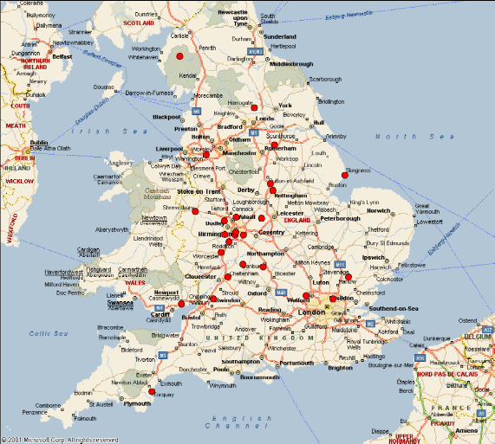

Map to show location of schools entering Cascade competition of schools

They all left, enthused, to prepare their own events, which took place in February and March 2007. Details were submitted to the School of Physics & Astronomy, and six teams were invited in to the University for a finalists event on April 25th, where they delivered their presentations to an audience of local GCSE students.

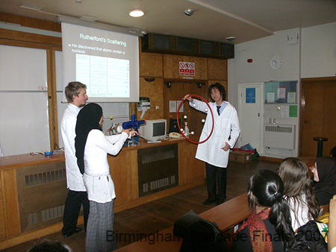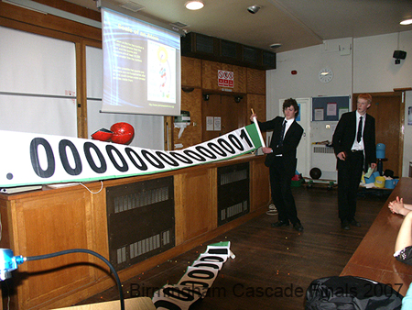

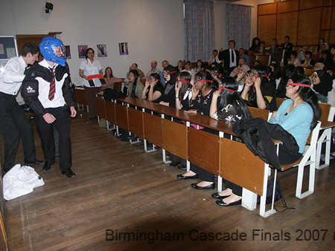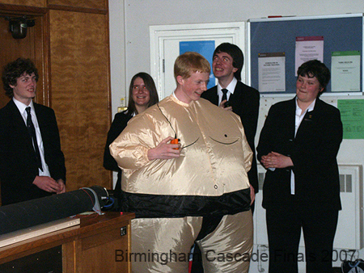

Some of the winning teams in action!

Quote from Prof Watkins:

It was a pleasure for us to host the event. All the teams were excellent ambassadors for their schools. They all showed a very mature approach to what must have been a very challenging experience for them.

The judges were impressed with the enthusiasm and commitment of the presenters, highly commending the innovative approaches used, the demonstrations and the drama, and the attempts to involve and engage the audience. We guess everyone learnt some new Physics too – always a good thing!

3 big awards of £650 were awarded to

Nottingham High School for Girls
St Peter’s Collegiate School, Wolverhampton
Worcester Royal Grammar School

And 3 smaller awards of £350 were awarded to

Lady Katharine Berkley School, S. Gloucestershire
Shrewsbury School
Torquay Boy’s Grammar School

We hope that the prize money will support a visit to CERN some time soon for the students involved.

Whilst there, they should be able to arrange to meet up with someone from the Birmingham group.

We also hope that all of the students who have been involved will want to develop and continue their interest in Physics - and that we may be able to welcome some of them onto campus as new undergraduates in the future!

Both the Masterclass event and the Cascade of Particle Physics competition were supported by PPARC

Lynne Long, Schools Liaison Officer, The School of Physics & Astronomy, University of Birmingham

